**In Partial Fulfilment**

**Of**

**Business Requirements**

**(On-the-Job Training)**

**Fortress Data Services Asya Philippines**

**To be submitted to:**

Sir Raymond Robles Villapando

**Company Supervisor**

**Submitted by:**

Alamag, Raphael P.

**Student Trainee**

**WORKOUT BUDDY**

**Description:** Workout buddy was an app that can help people with low self-esteem, who don’t have time, and who have stress, this will help them to be physically healthy and fit. Moreover, workout buddy has a variety of training exercises to be able to fully utilize your workout routine. As we are facing a lot of different diseases this time around. With this app, you can prevent any injuries, be actively living daily, and practically evade diseases.

**Purpose:** To ensure people are physically healthy and fit

**Intended Users:** From Teenagers and Adults

**Uses:** Its use is to help people with different training exercises that can fully activate your arms and legs and every part of your body.

**SWOT ANALYSIS**

**(Strengths, Weaknesses, Opportunities, Threats)**

* To be able to foresee an area you have to improve or an area you have an advantage

**STRENGTHS**

* It is convenient
* Can be resources
* Has a variety of exercise
* With the description of the benefits
* Steps to be followed
* Simple
* Cost-effective

**WEAKNESSES**

* Needed an Internet Connection
* Low Specs
* Simple
* Slow loading
* Slow Development Progress
* Bland Designs

**OPPORTUNITIES (to another developed app in the OJT)**

* It can be utilized with the backend
* Resources manageable to install
* Can be practically needed
* It can be useful for teenagers to adults
* Can be a source for a guide in a gym training

**THREATS**

* It is undeveloped
* It is not open for installment anytime soon
* Must be affiliated with the backend
* It is simple other than to an installed app

**Workout Buddy Functions and Planned**

**The Functionality of the Apps:**

* Workout buddy function was to utilize people getting into shape. Its function was to click the formatted categorization of text on the home screen. It is simple to see and viewed at the same time. For its account or to know your basic information, there was an icon menu on the right side that can be clicked and a drawer slider can be viewed together with settings, a progress bar, and a calendar

**In Development Planning:**

* Development Planning, Workout buddy is foreseeing active video tutorials made by professionals to showcase how this app can be trusted by the people who installed this app.
* The developer planned auto-update the app for any changes of specifications to fully integrate its capacity to help people to be fit and healthy
* The developer also planned to develop different sets of challenges to motivate and ensure achievement in their workouts
* As the on-the-job training has passed, the developer wants to see workout buddy as a fully functional application that can be installed and used by its consumer.
* Moreover, the developer also foresees an active pathway that can hire a physical trainer in a video online tutorial:

1. Aerobics
2. Zumba
3. Yoga

* Lastly, if the workout buddy will practically help people daily this will help the applications. To innovate and develop an online shop that can conveniently be an e-commerce business

**In Progress:**

* The developer is trying to make workout buddy into reality as the developers are making a backend that can work properly and come out for installation.
* The developer is progressing with a tutorial learning to connect its IU to a properly working applications
* With a discussion with professional tech support, the changes of making were in motion but with a small amount of understanding of the technicalities
* **Go language, pgAdmin, and Postman** have been in progress to gradually make it into action and posing to be able to have a response to the applications.
* Downloading Go language, and a database to implicate for a backend progression.

**Working UI (Workout Buddy) Initial:**

* The front-end Login and Signup Pages can be on text type keyboard
* The password in the app can be hidden and foreseen
* The drawer slider is functional
* The account of the client can be seen with its pictures and information and it can be also edited (initially)
* Categorization of training exercises can be view
* Benefits and Steps of every training exercise can also be viewed
* Challenges can be practiced and ready to initiate
* Beginner workout routine can be clicked
* Categorized workout out (abs, shoulder, and back, leg, arm, etc.)
* BMI Calculator to look up improvement
* Settings are initially working due to different sets of updates and restrictions
* Log-Out button is working

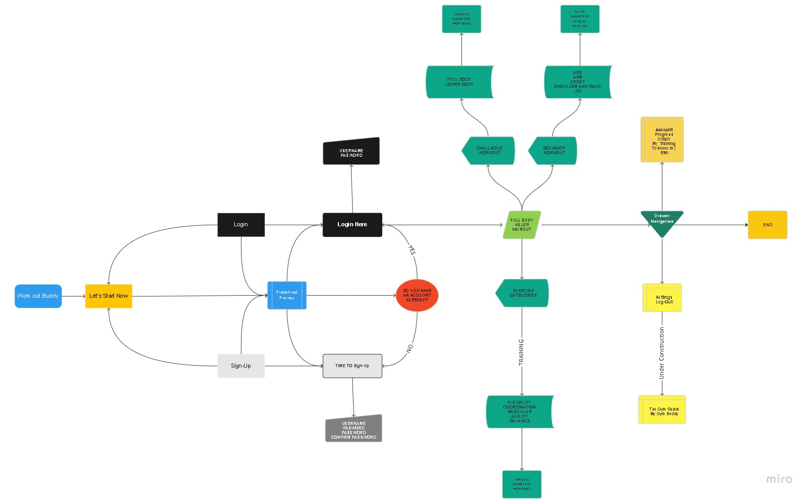**WORKOUT BUDDY FLOWCHART**